**Data Quality Report**

**Description of data:**

This dataset is the card transaction records of government staffs. It came from ‘The American Business Culture Guide 2018-2019.’ This dataset covers the time period of the year 2010. There are 10 fields and 96753 records in it.

**Fields Summary:**

Numeric Fields

|  |  |  |  |  |  |  |  |  |  |
| --- | --- | --- | --- | --- | --- | --- | --- | --- | --- |
| Field name | Field type | # records w/ value | % populated | # unique values | #  Records w/ 0 | Mean | Standard deviation | Min | Max |
| Cardnum | Numeric | 96753 | 100.00% | 1645 | 0 | 5142201786.82 | 55670.84 | 5142110002 | 5142847398 |
| Amount | Numeric | 96753 | 100.00% | 34909 | 0 | 427.89 | 10006.14 | 0.01 | 3102045.53 |

Categorical Fields

|  |  |  |  |  |  |  |
| --- | --- | --- | --- | --- | --- | --- |
| Field name | Field type | # records w/ value | % populated | # unique values | #  Records w/ 0 | Most common value |
| Date | Categorical | 96753 | 100.00% | 365 | 0 | 2/28/10 |
| Merchnum | Categorical | 93378 | 96.51% | 13092 | 231 | 930090121224 |
| Merch description | Categorical | 96753 | 100.00% | 13126 | 0 | GSA-FSS-ADV |
| Merch state | Categorical | 95558 | 98.76% | 228 | 0 | TN |
| Merch zip | Categorical | 92097 | 95.19% | 4568 | 0 | 38118 |
| Transtype | Categorical | 96753 | 100.00% | 4 | 0 | P |
| Fraud | Categorical | 96753 | 100.00% | 2 | 95694 | 0 |

Other Fields

|  |  |  |  |
| --- | --- | --- | --- |
| Field name | # records w/ value | # unique values | Most common value |
| Recnum | 96753 | 96753 | NA |

**Field Graphs**

**Numeric Fields:**

Field 1: Cardnum

Description: Cardnum represents the credit card number of transactions.

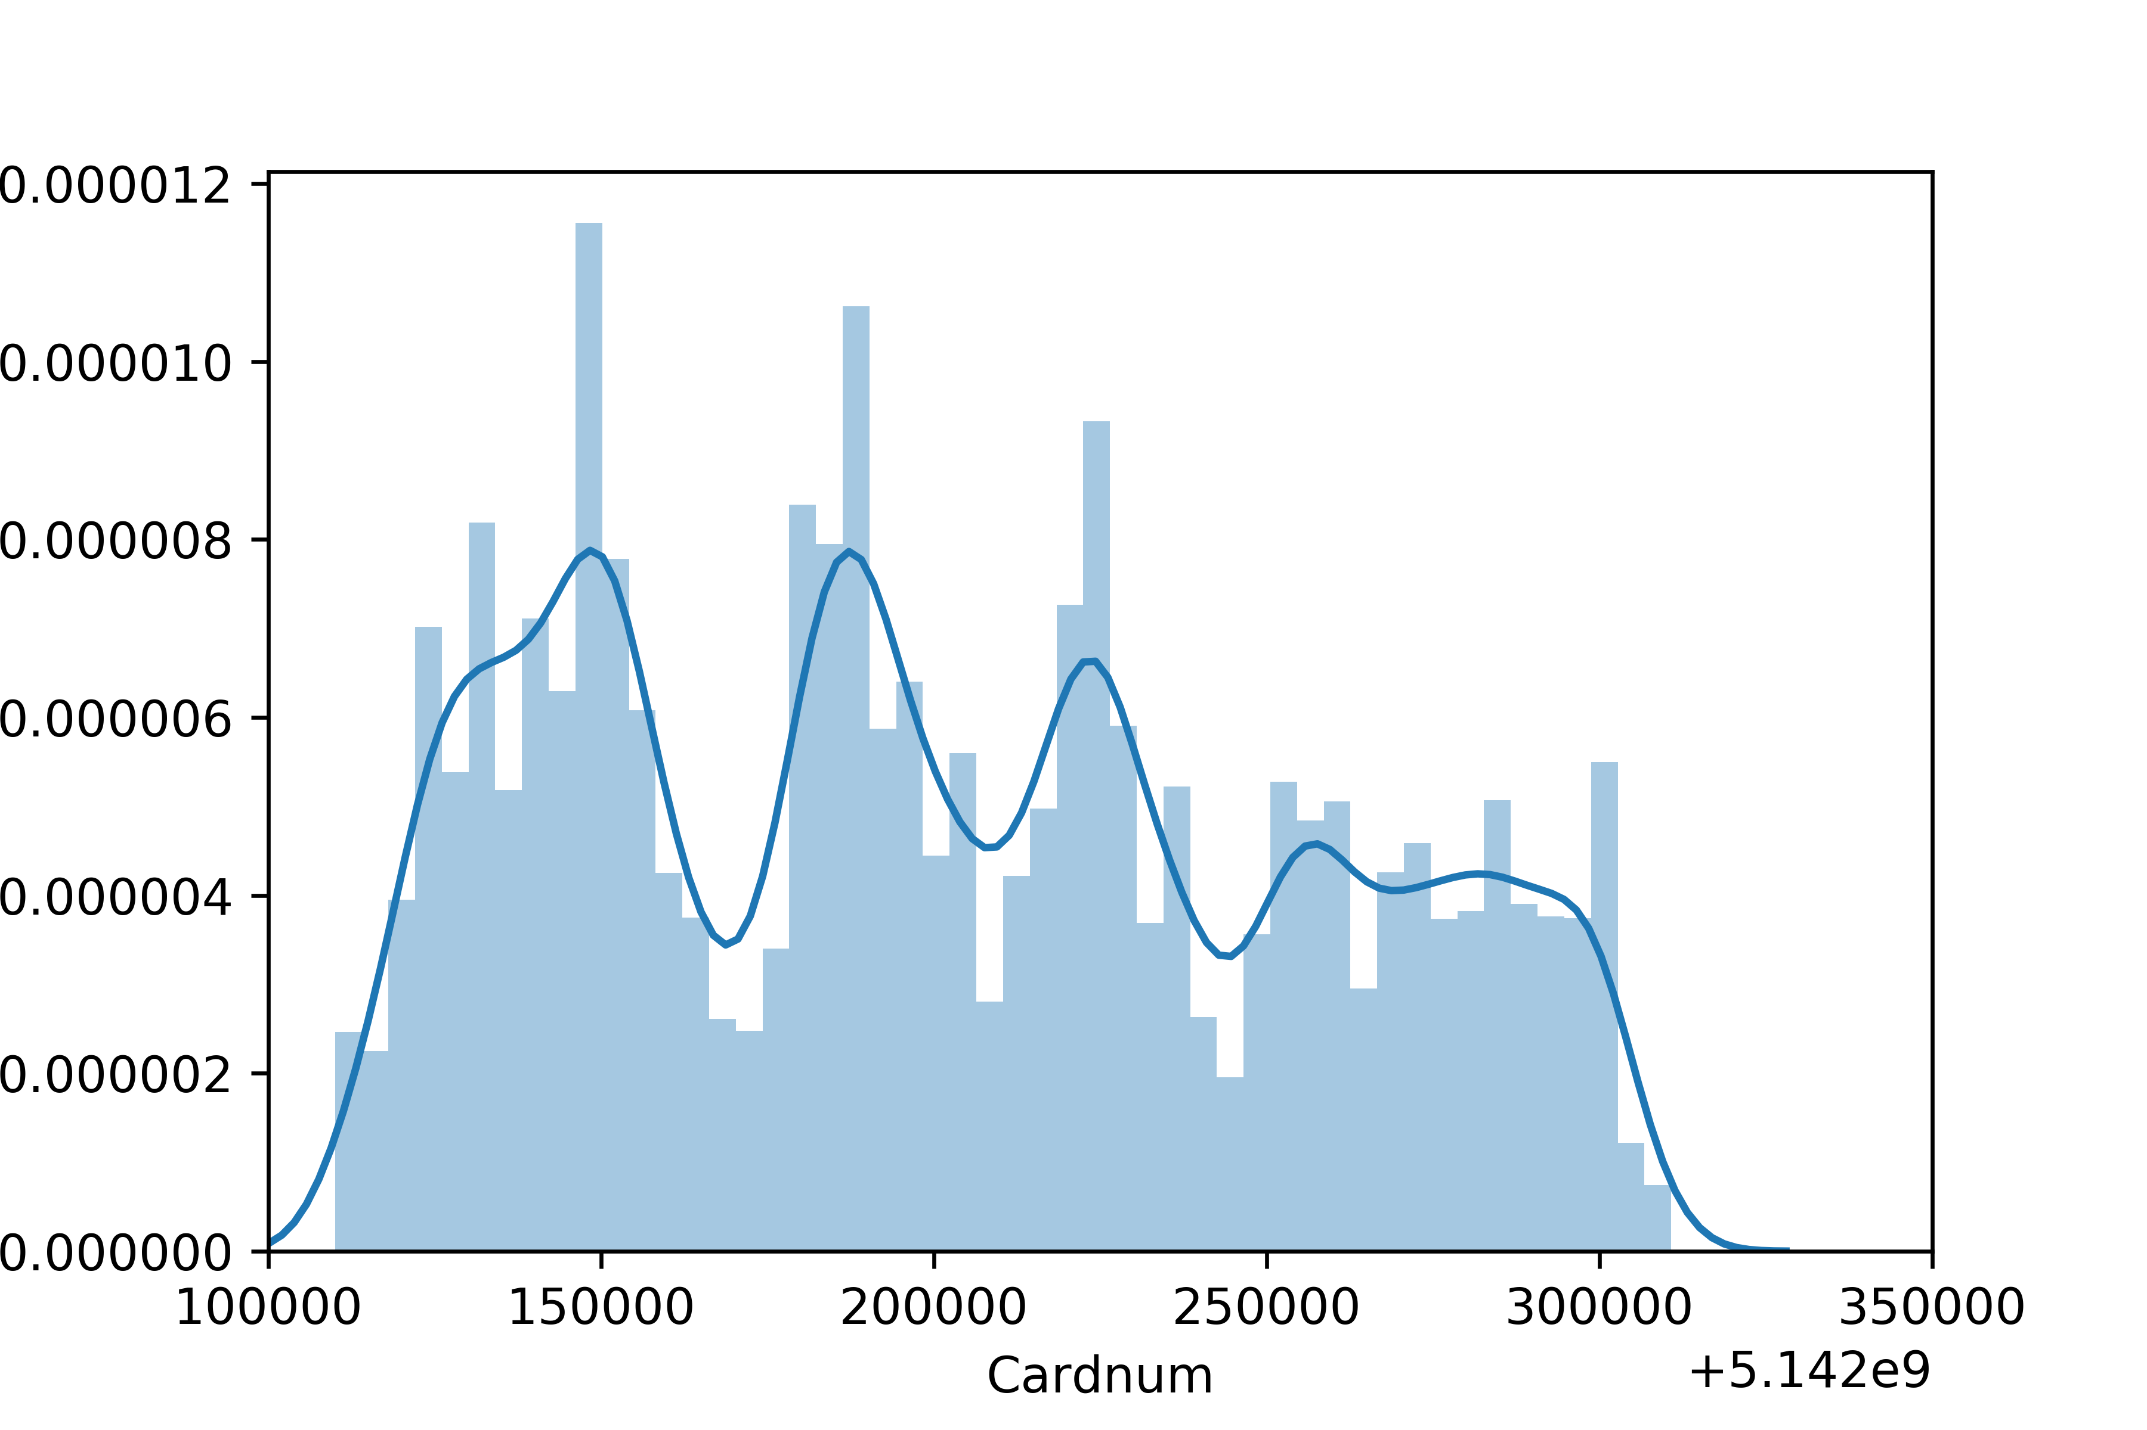

Field 2: Amount

Description: Amount is the money of transactions.

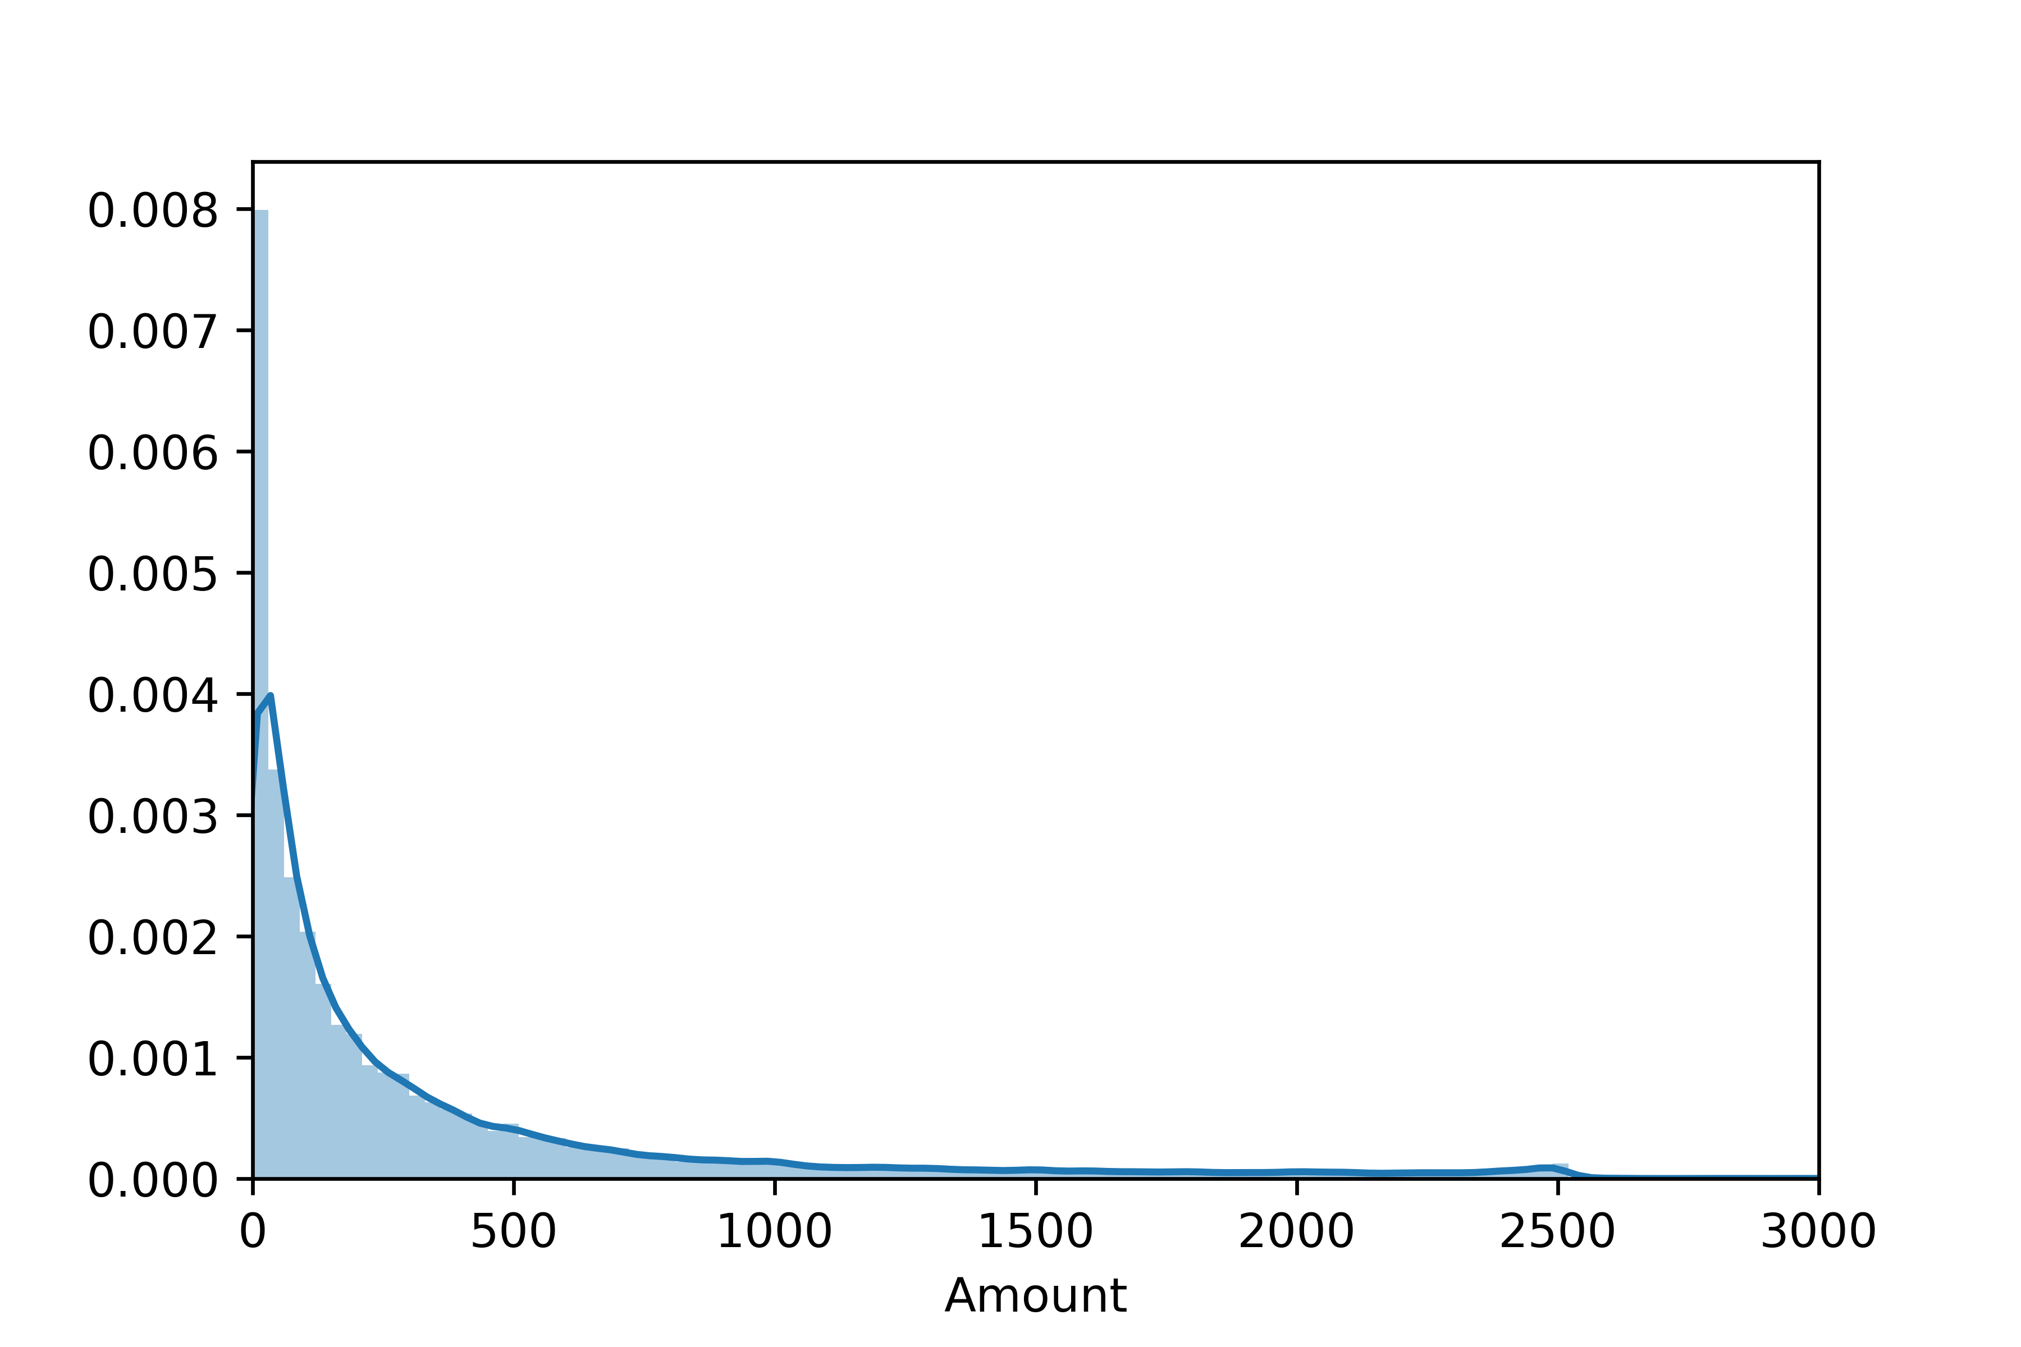

**Categorical Fields**

Field 3: Date

Description: Date represents the date when transactions happened.

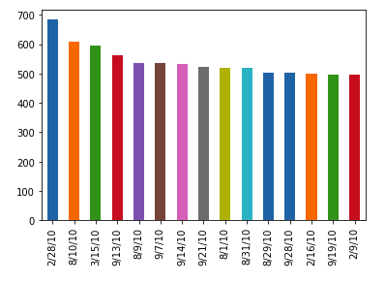

Field 4: Merchnum

Description: Merchnum represents the merchant number where transactions happened.

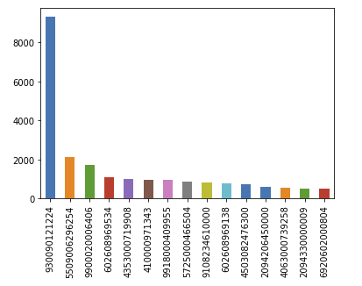

Field 5: Merch description

Description: Merch description is description of the merchant.

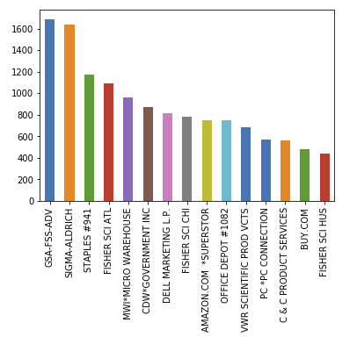

Field 6: Merch state

Description: Merch state is the state where the merchant locates.

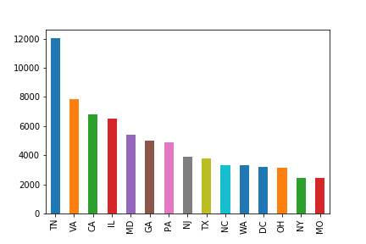

Field 7: Merch zip

Description: Merch zip is the zipcode number where the merchant belongs to.

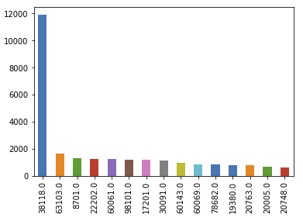

Field 8: Transtype

Description: Transtype is the transfer type of transactions.

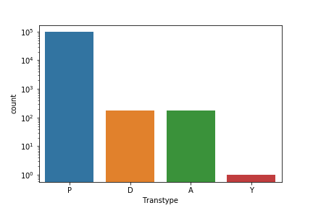

Field 9: Fraud

Description: Fraud is the fraud status of transactions.

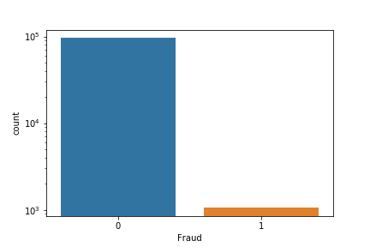

**Other Fields**

Field 10: Recnum

Description: Recnum is the index number of observations.